**Position Fixed Position Absolute**

Elements are placed in the browser Window Elements are placed on the page

So if the page scrolls the if we scroll the page, the elements will move

Position fixed elements don’t move

Element with higher z index will appear in front

Postion absolute co-ords are wrt to its container

**Position Relative**

the container element position should be set to postion relative & the we need to put the position absolute element inside this container so the Postion absolute co-ords are wrt to this container

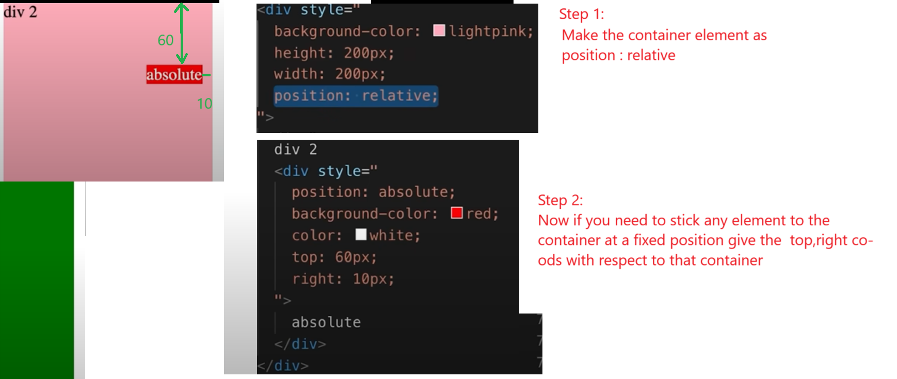



**Step 1 : add the timing div**

 <div class="thumbnail-row">

          <img class="thumbnail" src="images/thumbnail-1.webp" />

          <div class="video-time">14:20</div>

</div>

  .thumbnail-row {

    margin-bottom: 10px;

    position:relative;

  }

  .video-time{

    background-color: black;

    color:white;

    position: absolute;

    bottom: 8px;

    right: 5px;

  }